**Creating chrome logo(using macromedia free hand)**



Fig: Chrome Logo

**Steps involves in making this logo**

**Step 1**: (setting up the workspace)

Launch the Freehand MX software on your computer.

Create a New Document, Go to File -> New to create a new document.

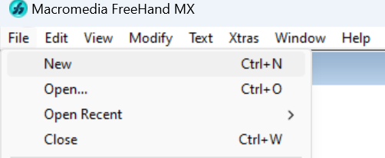

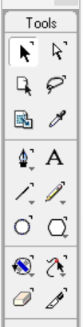**Step 2:** (Creating the Basic Shapes)

Draw the Outer Circle:

Select outer circle and click “ctrl + shift + d’ to duplicate the outer circle.

Hold ctrl + shift and resize the small circle as per your need.

**Step 3:** (draw lines)

Using Line tool or (N) draw 3 lines using guideline.

Use Divide tool form xtra operation. (select all)

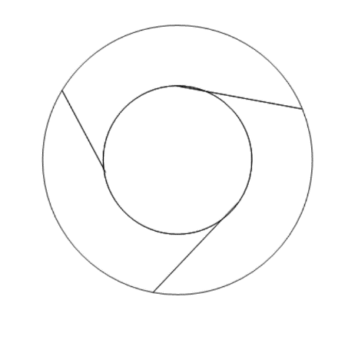

**Step 4:** (color the image)

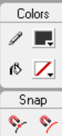Select the image and fill the color.

Using fill box option form tool box.



**Image dithering**

Image dithering is a technique used in digital imaging to create the illusion of color depth in images with a limited color palette. It is especially useful when the display device or the image format supports only a few colors, but a richer, more detailed image is desired.

Procedure:

Step 1: Bring an image to dither in the photoshop, file-> open new.

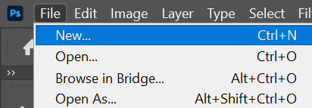

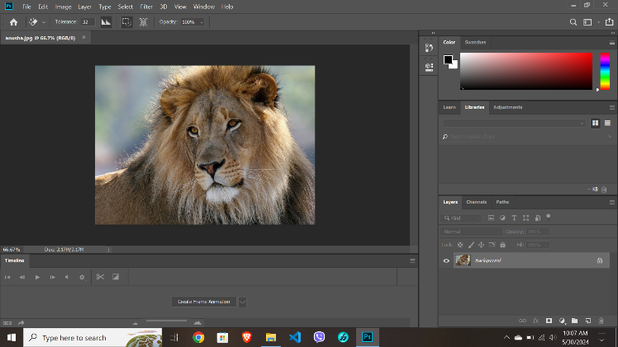

Step 2: Go to menu then Image -> mode-> Grayscale

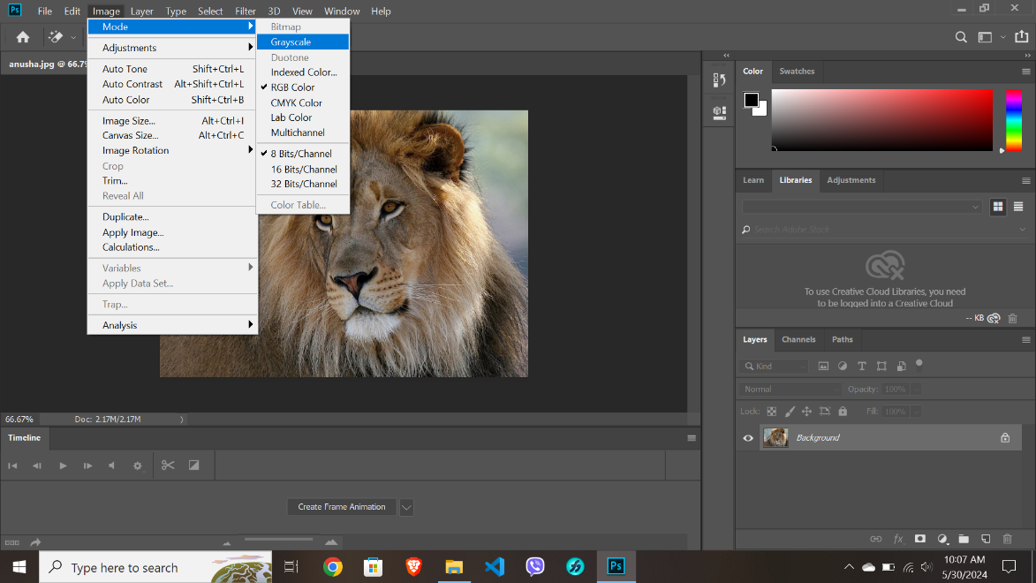

Step 3: Again go to menu -> mode -> bitmap.

Select pixel as per your need, and dither the image.

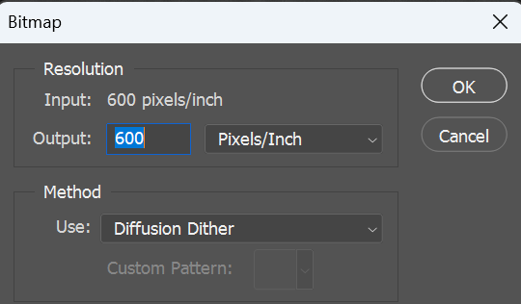

Final output:

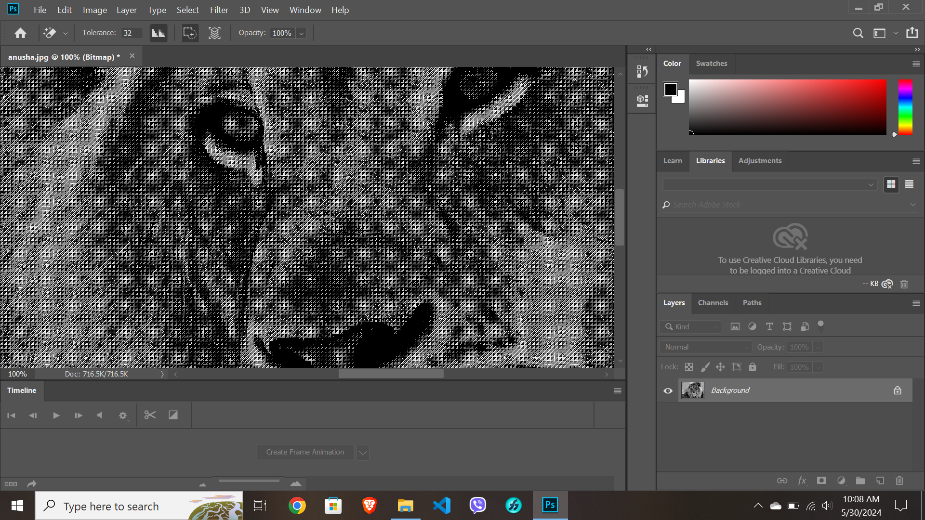

Conclusion:

Dithering significantly enhances the perceived visual quality of an image, even when the color palette is severely limited. By distributing the quantization error across neighboring pixels, the technique creates a smoother transition between colors, giving an impression of more shades and gradients than actually available.